**Ideation Phase**

**Define the Problem Statements**

|  |  |
| --- | --- |
| Date | 31 January 2025 |
| Team ID | LTVIP2025TMID59486 |
| Project Name | ShopEZ: One-Stop Shop for Online Purchases |
| Maximum Marks | 2 Marks |

**Customer Problem Statement Template:**

Create a problem statement to understand your customer's point of view. The Customer Problem Statement template helps you focus on what matters to create experiences people will love.

A well-articulated customer problem statement allows you and your team to find the ideal solution for the challenges your customers face. Throughout the process, you’ll also be able to empathize with your customers, which helps you better understand how they perceive your product or service.

Reference: <https://miro.com/templates/customer-problem-statement/>

**Example:**

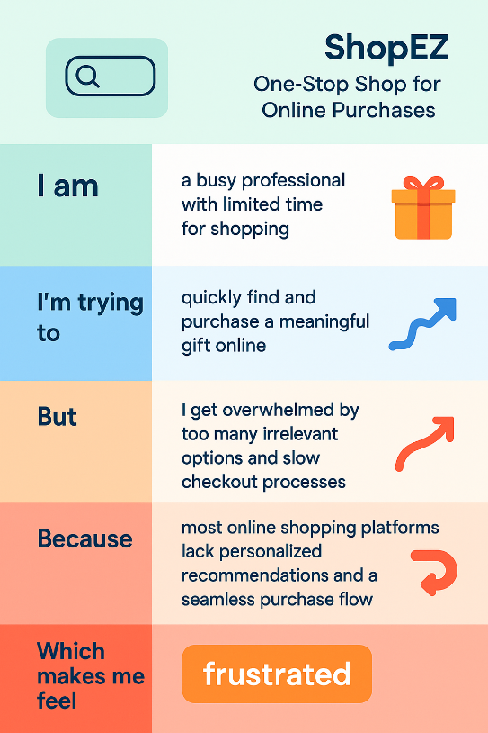

|  |  |  |  |  |  |
| --- | --- | --- | --- | --- | --- |
| **Problem Statement (PS)** | **I am (Customer)** | **I’m trying to** | **But** | **Because** | **Which makes me feel** |
| PS-1 | A busy working professional | Buy a thoughtful birthday gift for my friend | I don’t have time to search through multiple sites | I have a hectic schedule and limited time | Frustrated and overwhelmed |
| PS-2 | A customer looking for personalized shopping | Discover products that match my taste | Recommendations are often irrelevant | The system doesn't understand my preferences | Uninterested and disconnected |